Chapter13 Metals name: class:

1.了解金属的物理性质 general properties
物理性质：1. High melting point; 2. Great electric conductivity
3. malleable and ductile (延展性) 4. Great thermal conductivity 5. Strong
1. A substance, X, has the following properties.
1 It has a high melting point.
2 It conducts electricity in the solid and liquid states.
3 It is malleable. 4 It had a high density.
What is X? （ ）
A a ceramic B copper C graphite D sodium chloride
2. Which property is not considered a typical metallic property? （ ）
A good conductor of heat
B low melting point
C malleable (can be hammered into shape)
D strong

3. Which element is a metal? （ ）
 | charge on element ion | electrical conductivity
A | negative | low
B | positive | high
C | negative | high
D | positive | low

2.了解金属的化学性质 general properties
化学性质：Metallic (金属性) ：The ability of a particle to lose electrons
1. React with water: Ca(s) + 2 H₂O(l) → Ca(OH)₂ (aq) + H₂(g)
2. React with dilute hydrochloric acid :Mg(s) + HCl(aq) → MgCl₂ (aq) + H₂(g)
3. React rigorously with oxygen : 4 Li + O₂ → 2 Li₂O
4. Form basic oxide
1. What is the balanced chemical equation for reaction between calcium and water? （ ）
A $Ca+H_{2}O→CaOH+H_{2}$
B $Ca+H_{2}O→Ca(OH)_{2}+H_{2}$
C $Ca+2H_{2}O→CaOH+H_{2}$
D $Ca+2H_{2}O→Ca(OH)_{2}+H_{2}$
2. The following statements are made about the metals copper, iron, magnesium and zinc.
1 Their oxides are acidic.
2 They all conduct electricity in the solid state.
3 They all have high melting points.
4 They all react with dilute acids to form hydrogen.
Which statements are correct? （ ）
A 1 and 2 B 1 and 4 C 2 and 3 D 3 and 4

3. Three students, X, Y and Z, were told that solid P reacts with dilute acids and also conducts electricity.
The table shows the students suggestions about the identity of P.
X | Y | Z
copper | iron | graphite
Which of the students are correct? （ ）
A X, Y and Z B X only C Y only D Z only

3.从反应的剧烈程度判断reactive series (与冷水反应，稀盐酸，steam)
1. Metal react with cold water and steam
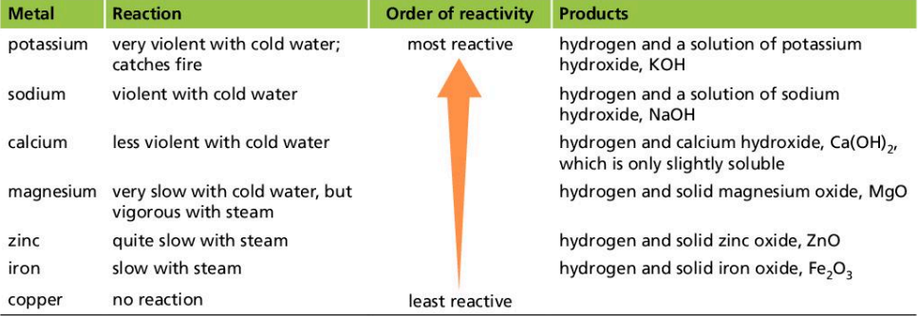
1. K , Na , Ca can react with cold water . 可以与冷水反应 ，反应变得不剧烈
2. Mg ,Zn ,Fe can react with steam
Mg(s) + H₂O(l) → MgO (s) + H₂(g)
2. Metal react with dilute hydrochloric acid
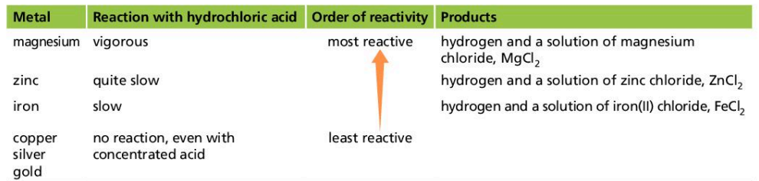
3. Metal react with oxygen
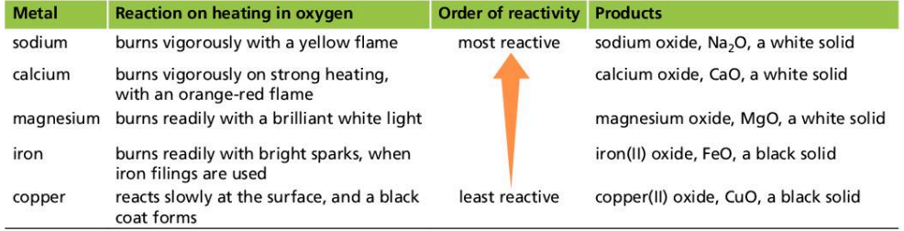
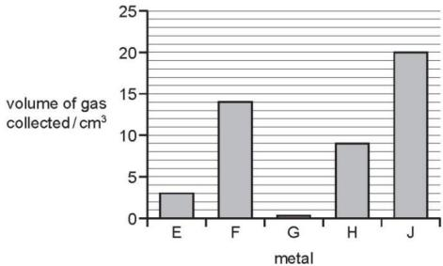
1. Samples of five different metals, E, F, G, H and J were reacted with dilute sulfuric acid using the apparatus shown.
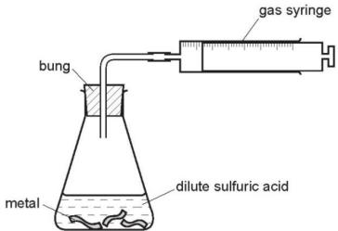

The volume of hydrogen gas collected after one minute was measured.
The results are shown on the bar chart.
What is the order of reactivity of the metals (most reactive first)? （ ）
A E,F,G,H,J
B G,E,H,F,J
C J,F,H,E,G
D J,H,G,F,E

2. Calcium reacts with cold water to produce hydrogen.
Lead reacts slowly when heated in air to form an oxide but has almost no reaction with steam.
Silver does not react with either air or water.
Zinc reacts when heated with steam to produce hydrogen.
What is the order of reactivity starting with the least reactive? （ ）
 | least reactive | most reactive
A | calcium | lead | zinc | silver
B | calcium | zinc | lead | silver
C | silver | lead | zinc | calcium
D | silver | zinc | lead | calcium

3. A reactivity series of metals is given below.
most reactive | metal name | symbol
 | sodium | Na
 | lithium | Li
 | magnesium | Mg
 | zinc | Zn
 | manganese | Mn
 | iron | Fe
least reactive | copper | Cu
 | rhodium | Rh
Which two metals will react most vigorously with cold water?
...................................................................................................................[1]
Which two metals will not react with dilute hydrochloric acid?
..................................................................................................................[1]
Deduce the formula of iron(III) sulfate.
..................................................................................................................[1]
What is the formula of a magnesium ion?
..................................................................................................................[1]

4. 从金属的置换反应来判断金属的reactivity series
Reactivity series: K , Na , Ca, Mg, Al, Zn, Fe , H ,Cu , Ag, Au
(Most reactive) (lest reactive)
Displacement reaction: 2 Al + Fe₂O₃ → 2Fe + Al₂O₃
2 Cu + AgNO₃ → 2Ag + Cu(NO₃)₂
The more reactive metal replaces the less reactive metal ion by losing electrons
更活泼的金属通过给电子的方式取代不活泼的金属
1. The results of two experiments are given.
1 Cobalt displaces manganese from an aqueous solution of a manganese salt.
2 Manganese displaces silver from an aqueous solution of a silver salt.
Three more experiments are carried out.
3 Cobalt is added to an aqueous solution of a silver salt.
4 Manganese is added to an aqueous solution of a cobalt salt.
5 Silver is added to an aqueous solution of a cobalt salt.
In which experiments does a reaction take place? （ ）
A 3 only B 3 and 4 C 4 and 5 D 5 only

2. Element Y reacts with copper(II) oxide to form copper.
Element Y will not react with zinc oxide. Copper has no reaction with zinc oxide.
What is the order of reactivity of these three elements, most reactive first?（ ）
A $Cu→Y→Zn$ B $Cu→Zn→Y$ C $Zn→Cu→Y$ D $Zn→Y→Cu$

3. One way of establishing a reactivity series is by displacement reactions.
A series of experiments was carried out using the metals lead, magnesium, zinc and silver. Each metal was added in turn to aqueous solutions of the metal nitrates.
Complete the table.
$✓=$ reacts $χ=$ does not react
 | metal
aqueous solution | lead Pb | magnesium Mg | zinc Zn | silver Ag
lead(II) nitrate |  | ✓ | ✓ | χ
magnesium nitrate
zinc nitrate
silver nitrate
Displacement reactions are redox reactions. On the following equation, draw a ring around the reducing agent and an arrow to show the change which is oxidation.
$$Zn+Pb^{2+}→Zn^{2+}+Pb$$
Complete the following ionic equation.
$$Zn+2Ag^{+}→……+……$$

5.从reactivity series 推测其反应现象
1. 更活泼的金属在与相同物质反应时反应现象更剧烈
2. 更活泼的金属可以取代更不活泼的金属离子
1. Silver is a less reactive metal than cadmium.
Cadmium is a less reactive metal than barium.
Which statement is correct? （ ）
A Barium does not react when heated with silver oxide.
B Cadmium displaces barium from a solution of barium chloride.
C Cadmium displaces silver from a solution of silver nitrate.
D Cadmium reacts when heated with barium oxide.

2. Displacement reactions occur between metals and metal ions.
Displacement reactions can be used to determine the order of reactivity of metals such as lead (Pb), nickel (Ni), and silver (Ag).
The ionic equation for a displacement reaction is shown.
$$Ni(s)+Pb^{2+}(aq)→Pb(s)+Ni^{2+}(aq)$$
The ionic half- equations for this reaction are shown.
$$Ni(s)→Ni^{2+}(aq)+2e^{−}$$
$$Pb^{2+}(aq)+2e^{−}→Pb(s)$$
The ionic half- equations show that electrons are donated by nickel atoms and accepted by lead ions.
Identify the reducing agent in the displacement reaction.
Give a reason for your answer. reducing agent. reason.
....................................................................................................................................................................................................................................................................[2]
What is the general term given to the type of reaction in which electrons are transferred from one species to another?
...................................................................................................................................[1]
The ionic equation for another displacement reaction is shown.
$$Pb(s)+2Ag^{+}(aq)→2Ag(s)+Pb^{2+}(aq)$$
Write the two ionic half- equations for this reaction.
1 .................................................................................................................................
2 ................................................................................................................................[2]
Use the information to put the three metals lead, nickel and silver in order of reactivity.
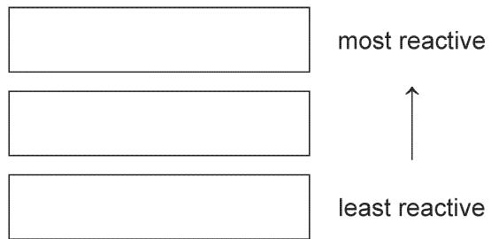[1]

6. Extraction of metals
Ore (矿石): The rocks from which we obtain metals
Hematite (铁矿石) containing: 1. Fe₂O₃ 2. Silica(石英): SiO₂
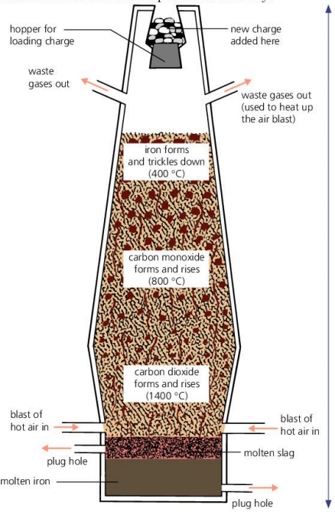
Materials：1. Hematite 2. Coke (焦炭) 3. CaCO₃
Process:
Stage 1:The coke burns to give carbon dioxide and heat
C + O₂ → CO₂
Stage 2: Carbon dioxide is reduced to carbon monoxide
C(s) + CO₂(g) → 2CO (g)
Stage 3: Carbon monoxide reduces iron(lll) oxide to iron
Fe₂O₃ + CO → Fe + CO₂
Stage 4: lmpurities are removed as slag(炉渣)
Thermal decomposition: CaCO3 → CaO + CO2
CaO + SiO2 → CaSiO3 (slag) 用basic oxide(CaO)与酸性氧化物(SiO₂)反应
1. The Basic Oxygen Process converts iron into steel.
In step 1, oxygen is blown into impure molten iron.
In step 2, oxides are removed by reaction with calcium oxide.
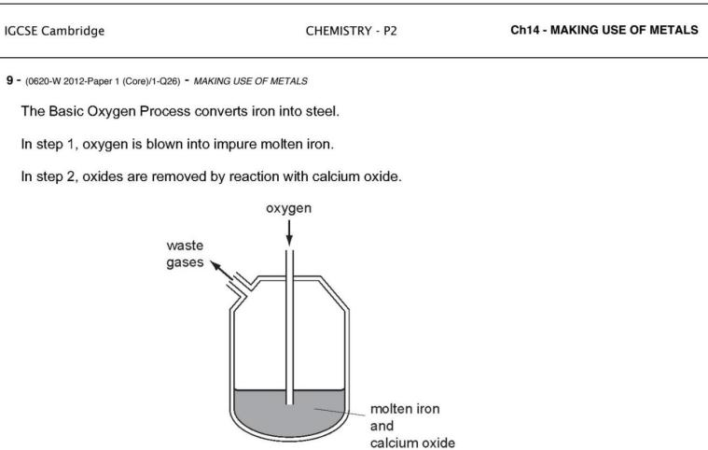
Which chemical reaction takes place in step 1 and which type of oxides are removed in step 2? （ ）
 | chemical reaction in step 1 | type of oxides removed in step 2
A | carbon is converted to carbon dioxide | acidic
B | carbon is converted to carbon dioxide | basic
C | iron is converted to iron(III) oxide | acidic
D | iron is converted to iron(III) oxide | basic

2. Iron is extracted from its ore in a Blast Furnace.
Hematite, coke, limestone and hot air are added to the furnace.
Which explanation is not correct? （ ）
A Coke burns and produces a high temperature.
B Hematite is the ore containing the iron as iron oxide.
C Hot air provides the oxygen for the burning.
D Limestone reduces the iron oxide to iron.

3. Which substance is not involved in the extraction of iron from hematite? （ ）
A carbon B carbon monoxide C calcium carbonate D nitrogen

4. The diagram shows a blast furnace.
In which part is iron ore changed to iron? （ ）
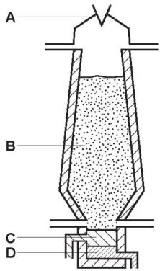

Iron is extracted from its ore using coke in a blast furnace.
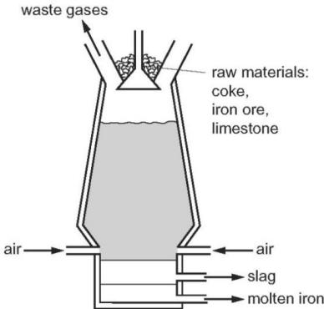
Name the ore of iron which is mainly iron(III) oxide.
..................................................................................................................[1]
Describe the reactions occurring in the blast furnace.
In your answer, include
two reasons for using coke in the blast furnace,- a chemical equation for the reduction of iron(III) oxide,- an explanation for using limestone in the blast furnace.


7. 从金属活泼性来判断某金属的矿石不能被C还原。
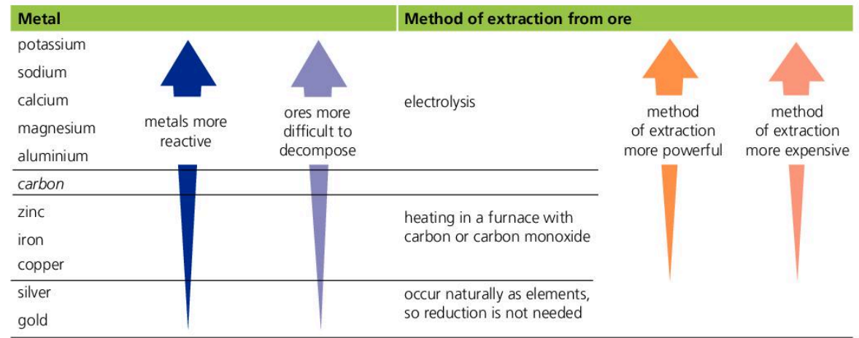
P, Na ,Ca, Mg , Al 比C 活泼无法用C还原， 而是得用电解方式分解
C 比 Zn, Fe , Cu 活泼. 可以用C在blast furnace 中还原。
1. Which statement about the extraction of iron from its ore is correct? （ ）
A Iron is more difficult to extract than zinc.
B Iron is more difficult to extract than copper.
C Iron is easy to extract because it is a transition metal.
D Iron cannot be extracted by reduction with carbon.

2. Many metals are extracted from their ores by heating the metal oxide with carbon.
Which metal cannot be extracted using this method? （ ）
A aluminium B copper C iron D zinc

3 . Which word equation represents a reaction which occurs? （ ）
A sodium oxide $​^{+}$ carbon $→$ sodium $​^{+}$ carbon dioxide
B sodium oxide $​^{+}$ iron $→$ sodium $​^{+}$ iron(II) oxide
C iron(II) oxide $​^{+}$ copper $→$ iron $​^{+}$ copper(II) oxide
D iron(III) oxide $​^{+}$ carbon $→$ iron $​^{+}$ carbon dioxide

8. Rusting of metals
Rusting requires oxygen and water 金属生锈需要氧气和水
1. The diagrams show experiments involving the rusting of iron.
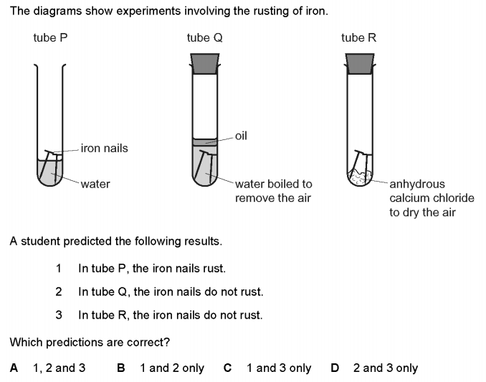
A student predicted the following results.
1 In tube P, the iron nails rust.
2 In tube Q, the iron nails do not rust.
3 In tube R, the iron nails do not rust.
Which predictions are correct? （ ）
A 1,2 and 3 B 1 and 2 only C 1 and 3 onlyD D 2 and 3 only

2. A piece of zinc is attached to the hull of a steel boat.
Steel is an alloy of iron.
Which statement explains why the zinc prevents the iron from rusting? （ ）
A Zinc is less reactive than iron, and iron is less likely to lose electrons than zinc.
B Zinc is less reactive than iron, and iron is more likely to lose electrons than zinc.
C Zinc is more reactive than iron, and iron is less likely to lose electrons than zinc.
D Zinc is more reactive than iron, and iron is more likely to lose electrons than zinc.

9. Prevention of the Rusting of metals
预防金属生锈的方式：1.Paint 2. Grease 3. Plastic
原理：Create a physical barrier bewteen metal and oxygen, water建立物理屏障
4. Galvanising (镀锌) ：Let metal coated with zinc 用锌镀在金属表面
原理：
Sacrificial protection 牺牲保护法: 用更活泼的金属被生锈以此保护不活泼的金属
The more reactive metal prevent the other metal lose electrons
1. Boats made from steel can be protected from rusting by attaching blocks of a more reactive metal to the hull of the boat.
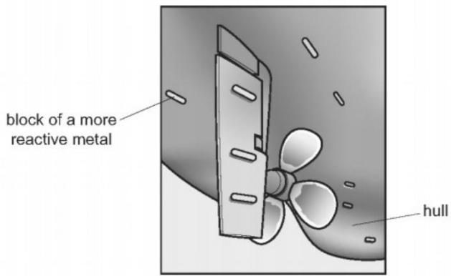
Which statement is correct? （ ）
A Copper is used for the blocks because it does not react with water.
B Magnesium is not used for the blocks because it reacts with steel.
C The metal used for the blocks loses electrons more easily than steel.
D This form of protection from rusting is called galvanising.

2. Steel nails rust in the presence of air and water. Plan an investigation to:
show that coating steel nails with paint helps to protect the nails from rusting
show that coating steel nails with zinc helps to protect the nails from rusting
determine which coating is more effective at protecting steel nails from rusting.
You are provided with:
uncoated steel nails
steel nails coated with paint
steel nails coated with zinc
common laboratory apparatus.
The metal iron and the alloy steel are commonly used materials. A problem with them is that they rust.
(a)How does painting iron and steel prevent rusting?
............................................................................................................................... [1]
(b)Magnesium blocks can be attached to the bottom of steel boats.
Explain how the magnesium blocks prevent the whole of the bottom of the boat from rusting.
...............................................................................................................................
...............................................................................................................................[2]
(c)Replacing the magnesium blocks with copper blocks does not prevent rusting.
Explain why the copper blocks do not prevent rusting.
...................................................................................................................................
................................................................................................................[1]

10. 金属的应用与其性质的关系
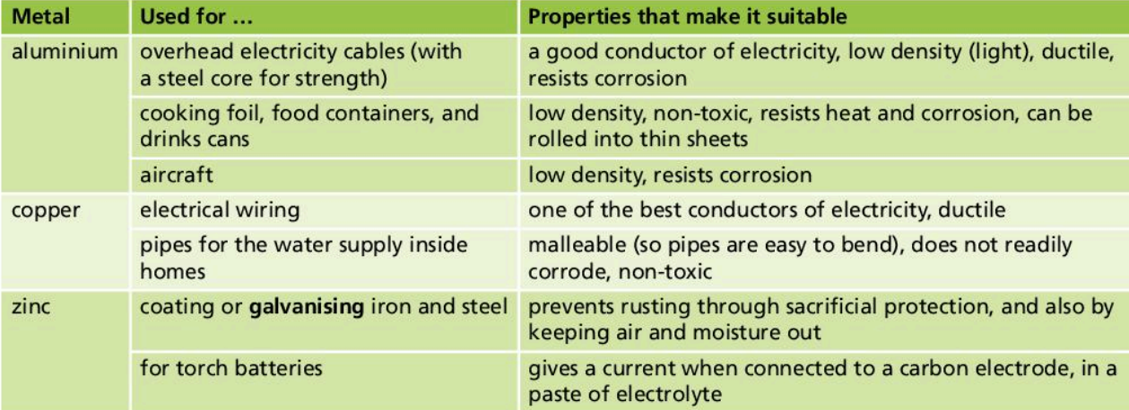
1. Which row shows uses of the metals listed? （ ）
 | aluminium | copper | mild steel
A | aircraft manufacture | food containers | cutlery
B | cutlery | electrical wiring | chemical plant
C | electrical wiring | aircraft manufacture | cooking utensils
D | food containers | cooking utensils | car bodies

2. Which statement about the uses of metals is not correct? （ ）
A Aluminium is used in aircraft because of its strength and good electrical conductivity.
B Copper is used in electrical wiring because of its good electrical conductivity.
C Stainless steel resists corrosion and is used to make cutlery.
D Transition elements are often used as catalysts.
3. Which statement about the uses of metals is correct? （ ）
A Aluminium is used in the manufacture of aircraft because of its strength and high density.
B Copper is used in electrical wiring because of its strength and high density.
C Mild steel is used in the manufacture of car bodies because of its strength and resistance to corrosion.
D Stainless steel is used in the construction of chemical plant because of its strength and resistance to corrosion.

11.Alloy的结构及其坚硬的原因
Alloy :mixture of a metal with at least one other element
合金是金属与其他元素的混合物 Harder and stronger
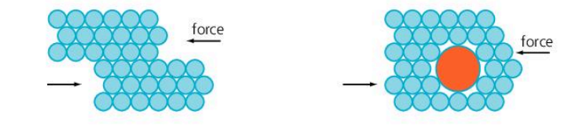
原因：When an alloy is made, new atoms enter the lattice.
The layers of metal ions cannot slide so easily. (金属离子层无法轻易移动)
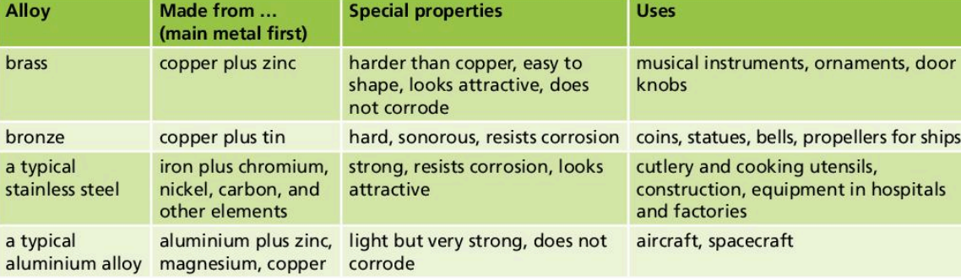
1. The diagrams show the structure of two substances used to make electrical conductors.
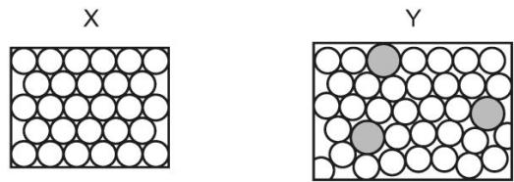
Which statement correctly describes X and Y? （ ）
A X is a pure metal and Y is a compound.
B X is a pure metal and Y is an alloy.
C X is a solid and Y is a liquid.
D X is harder and stronger than Y.

2. Which row describes the uses of mild steel and stainless steel? （ ）
 | mild steel | stainless steel
A | car bodies, cutlery | chemical plant, machinery
B | car bodies, machinery | chemical plant, cutlery
C | chemical plant, cutlery | car bodies, machinery
D | chemical plant, machinery | car bodies, cutlery

3. Stainless steel is an alloy of iron, carbon and other metals.
Which row is correct? （ ）
 | stainless steel is harder than pure iron | stainless steel resists corrosion better than pure iron
A | ✓ | ✓
B | ✓ | ×
C | × | ✓
D | × | ×

4. Which row describes the use of an alloy and the property upon which the use depends? （ ）
 | alloy | use | property
A | mild steel | cutlery | resistant to corrosion
B | mild steel | machinery | strong
C | stainless steel | cutlery | low density
D | stainless steel | machinery | good conductor of electricity

5. Zinc alloys have been used for over 2500 years.
Explain the phrase zinc alloy.
.......................................................................................................................................
.................................................................................................................................. [1]
(ii) Making alloys is still a major use of zinc. State one other large scale use of zinc.
.......................................................................................................................................
...................................................................................................................................[1] (iii) Describe the bonding in a typical metal, such as zinc, and then explain why it is malleable. You may use a diagram to illustrate your answer.
.......................................................................................................................................
......................................................................................................................................
.......................................................................................................................................

12. 氧化铝保护膜
1. A strip of aluminium is placed into a test- tube containing aqueous lead(II) nitrate and left for several minutes.
Aluminium is higher than lead in the reactivity series.
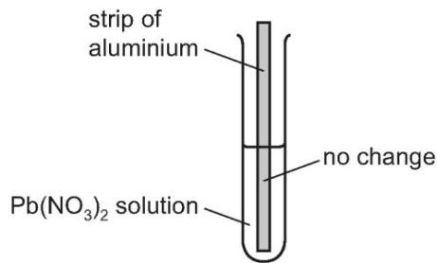
Which statement explains why lead is not displaced by this strip of aluminium? （ ）
A A thin insoluble layer of aluminium nitrate forms on the aluminium.
B Nitrate ions are reduced in aqueous solution.
C The ionic bonds between lead and nitrate ions are too strong.
D There is an unreactive oxide layer on the aluminium.

2. Why is aluminium metal unreactive with air? （ ）
A It is covered with a layer of oxide.
B It is low in the reactivity series.
C It is produced by electrolysis of its oxide.
D It melts at a high temperature.

